0 Hour Done
Introduction to Machine Learning (ML)

Machine Learning is one of the most significant technologies of the 21st century. It has revolutionized the business sector, offering new ways to analyze data and make predictions.
The goal of this video is to help beginners understand the fundamental concepts of machine learning and provide practical experience in building machine learning models.
Course Structure

Overview:
First, you'll learn the basics of machine learning, including essential algorithms.
You'll be introduced to concepts such as:
Linear Regression
Logistic Regression
Decision Trees
Support Vector Machines (SVMs)
Reinforcement Learning
Principal Component Analysis (PCA)
Regularization
Feature Selection
Finally, you will gain insights into the Machine Learning Roadmap for 2021, which is a guide for further learning and application.
Machine Learning Explanation (Animated Intro)

Humans learn from their experiences, but what if machines could do the same?
Machine Learning (ML) involves training machines to learn from data (past experiences) and perform tasks without explicit programming.
Unlike basic programming, ML enables machines to understand and reason based on patterns from past data.
Case Study - Paul and Music Preferences

Paul's Music Preferences:
Paul listens to new songs and either likes or dislikes them based on song characteristics like tempo and intensity.
For simplicity, we’ll use two features:
Tempo (x-axis: relaxed to fast)
Intensity (y-axis: light to soaring)
Based on these features, we can categorize songs Paul likes (fast tempo & soaring intensity) and dislikes (relaxed tempo & light intensity).
Prediction Example

Song A: Has fast tempo and soaring intensity.
Based on previous data, Paul likes Song A.
Song B: Has medium tempo and medium intensity.
The prediction isn’t as clear.
A simple K-Nearest Neighbors (KNN) algorithm can be used to classify Song B. By examining nearby data points, the majority classification (likes or dislikes) is determined.
Introduction to Machine Learning Algorithm - K-Nearest Neighbors (KNN)

KNN is an algorithm used for classification, where the data point (Song B) is classified based on the majority label of its nearest neighbors.
Conclusion: If most of the nearest points are labeled as "likes", the new data (Song B) will also be classified as "like".

Supervised Learning vs Unsupervised Learning

Supervised Learning:
It uses labeled data to train the model.
Example: You’re given coins of three different currencies with weights. The task is to predict the currency based on the weight of a coin.
The model learns to associate specific weights with specific currencies (labels).
If the model is given a new coin (weight = 3g), it will predict it’s a 1 rupee coin.
Key Point: The model learns from labeled data, associating features (weight) with labels (currency).
Unsupervised Learning:
Unlike supervised learning, unsupervised learning deals with unlabeled data. The model identifies patterns or structures in the data on its own.
Example: A cricket dataset of players’ runs and wickets is used to identify two clusters:
One cluster of batsmen (high runs, low wickets)
Another cluster of bowlers (low runs, high wickets)
The model doesn’t know about the labels (batsmen and bowlers) but finds the patterns based on features (runs and wickets).
Key Difference:
Supervised Learning: Labeled data helps train the model.
Unsupervised Learning: The model works with unlabeled data and identifies patterns on its own.
Reinforcement Learning

Reinforcement Learning is a type of machine learning where an agent learns to make decisions by receiving rewards or penalties based on actions it takes.
Example:
You show a system an image of a dog, and it incorrectly classifies it as a cat.
You give negative feedback (it's a dog, not a cat).
The machine learns from this feedback and, in the future, will correctly classify a dog when presented with similar data.
Machine Learning Flowchart

Flow:
Input data → Machine Learning Model → Output.
If the output is correct, it is taken as the final result.
If incorrect, feedback is given to the model, and the process repeats until the model learns to predict accurately.
Quiz Time

A short quiz encourages viewers to think about real-world scenarios where supervised or unsupervised learning is used:
Scenario 1: Facebook recognizing a friend in a picture from tagged photos → Supervised Learning.
Scenario 2: Netflix recommending movies based on past choices → Supervised Learning.
Scenario 3: Analyzing bank data for suspicious transactions → Unsupervised Learning (detecting fraud without labels).
Why Machine Learning is Possible Today

Data Availability:
With the rise of the internet, enormous amounts of data are generated every minute through online transactions, social media activities, etc.
Computational Power:
Advances in computer memory and processing power allow machines to handle vast amounts of data and process it quickly, making machine learning feasible on a large scale.
Applications of Machine Learning

Healthcare: Predictive diagnostics for doctors.
Sentiment Analysis: Tech companies analyze social media to determine public sentiment.
Fraud Detection: Machine learning helps detect fraudulent transactions in the financial sector.
Customer Churn Prediction: Used in e-commerce to predict and reduce customer churn.
Surge Pricing in Ride-Sharing: Companies like Uber use machine learning models to adjust prices in real-time based on demand, availability, and other factors.
Interactive Engagement

The audience is encouraged to share their experiences or thoughts on where they have seen machine learning being applied in everyday life.
Conclusion

The video concludes by summarizing the basics of machine learning, emphasizing its significance and potential applications in real life. The course aims to provide you with a deep understanding and hands-on experience in building machine learning models.
This video provides a foundational overview of machine learning (ML), covering key concepts, types of machine learning, and their applications. Here's a breakdown:
- What is Machine Learning?
Machine learning focuses on creating algorithms that allow machines to learn from data and improve from experience. It’s used in various applications like voice control, automated tasks, and smart systems (e.g., Amazon Echo).
- Difference Between AI, Machine Learning, and Deep Learning:
  - Artificial Intelligence (AI): Refers to systems mimicking human behavior to automate and enhance tasks. Examples include IBM Deep Blue, electronic game characters.
  - Machine Learning (ML): A technique in AI that uses statistical methods to enable machines to learn from past data and make predictions.
  - Deep Learning: A subset of ML, deep learning utilizes algorithms (such as neural networks) that allow models to train themselves and perform complex tasks, like AlphaGo or speech recognition.
- How Machine Learning Works:
The process starts with training data, which is used to train a machine learning algorithm. The model is then tested using new data to make predictions. If the predictions are incorrect, the model is retrained until it achieves the desired accuracy.
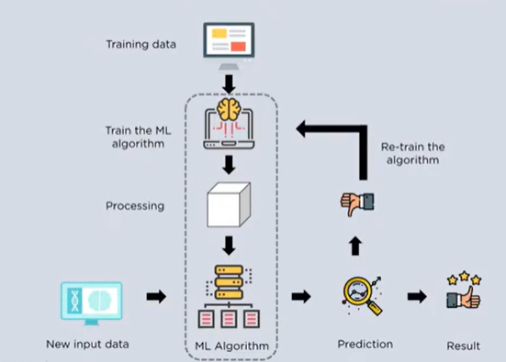
- Types of Machine Learning:
  - Supervised Learning: The model is trained using labeled data (e.g., recognizing apples based on features like size and color).
  - 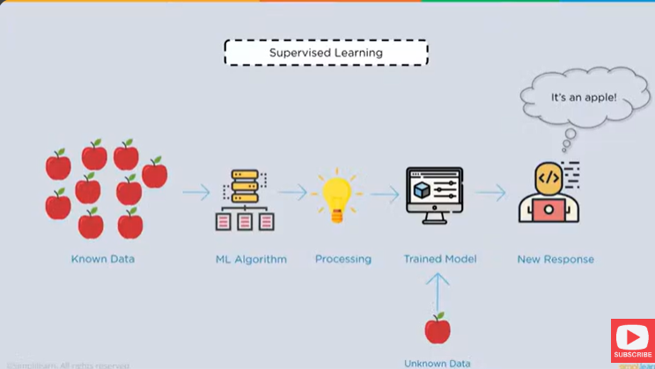

  - Unsupervised Learning: The model identifies patterns in unlabeled data (e.g., grouping fruits based on similarities without prior knowledge of their labels).
  - 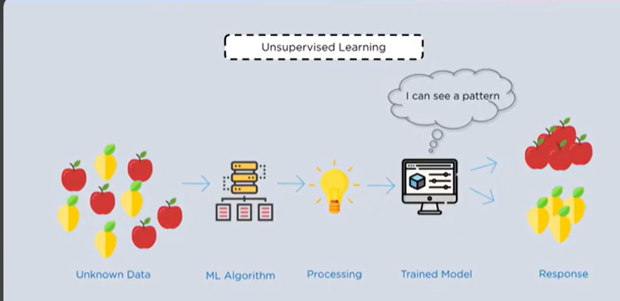
- Popular ML Algorithms:
  - Supervised Learning: Polynomial regression, random forest, linear regression, logistic regression, decision trees, k-nearest neighbors, Naive Bayes.
  - 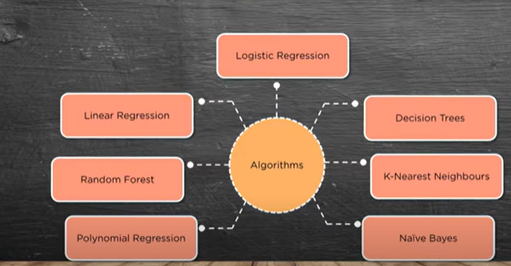
  - Unsupervised Learning: K-means clustering, singular value decomposition, fuzzy clustering, hierarchical clustering, principal component analysis.
  - 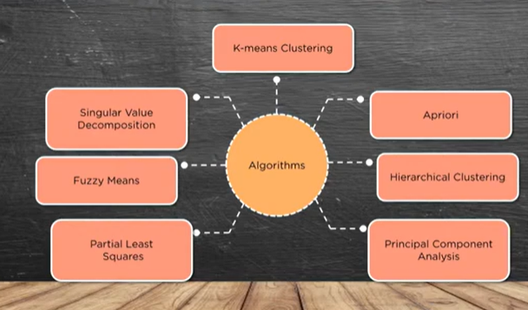
- Pre-requisites for Learning ML:
  - Basic programming skills
  - Knowledge of statistics, probabilities, and linear algebra
  - Understanding of calculus, particularly differential equations
  - Data wrangling and cleaning skills to prepare datasets for training.
- Applications of Machine Learning:
ML is used in:
  - Object Detection and Image Segmentation: Identifying objects in images, such as detecting cats in a picture.
  - Automatic Translation: Translating symbols or text from one language to another.
  - Real-world systems: Number plate detection, speech recognition, and more.
It seems like you are going through an explanation of machine learning, specifically focusing on linear regression, its types, and the implementation of multiple linear regression. Here's a summary of what you’ve covered so far:
- Machine Learning Overview: Machine learning enables machines to learn from past data and improve over time. It includes various techniques like AI, machine learning, and deep learning, each having its own scope and purpose.
- Types of Machine Learning:
  - Supervised Learning: Involves training a model using labeled data, where the outcome (dependent variable) is already known. Algorithms like linear regression, decision trees, and k-nearest neighbors are used for supervised learning.
  - Unsupervised Learning: The model tries to find patterns in data without labeled outcomes. Techniques like k-means clustering are common.
  - Reinforcement Learning: The model learns by receiving positive or negative feedback based on its actions.
- Linear Regression: Linear regression is a statistical model used to predict the relationship between independent and dependent variables
- it examines two factors
  - 1. which variables in particular are significant predictors of the outcome variables ?
  - 2. how significant is the regression line to make prediction with the highest possible accuracy ?
  - Simple Linear Regression: Predicts an outcome based on one independent variable (e.g., rainfall predicting crop yield).
  - Multiple Linear Regression: Extends simple linear regression by involving multiple independent variables to predict the dependent variable (e.g., rainfall, food supply, and harvest time affecting crop yield).
  - Polynomial Regression: Instead of fitting a straight line, it fits a curve to the data.
- Mathematical Foundations:
  - The equation for simple linear regression is y=mx+c, where m is the slope, x is the independent variable, and c is the y-intercept.
  - The slope and intercept are calculated using formulas involving summation (e.g., the sum of squared errors).
  - 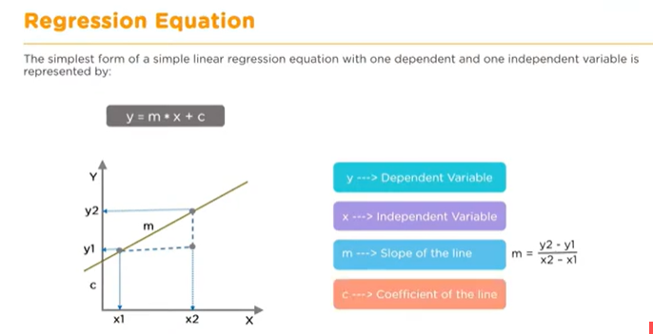
  - 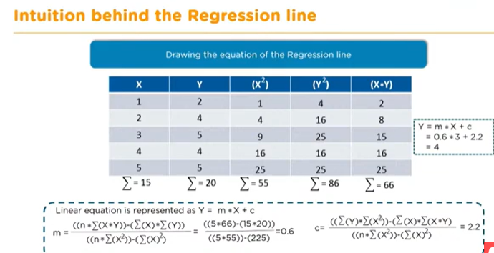

  - 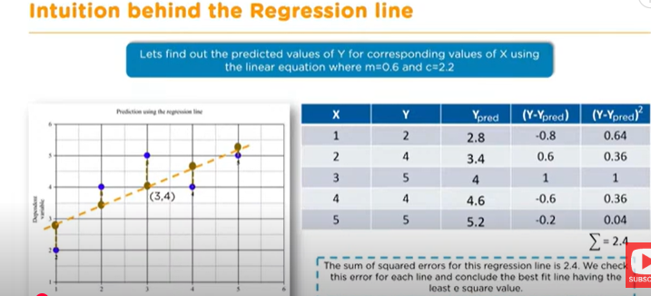Real-world Applications:
  - Linear regression can be applied to predict economic growth, housing prices, sports scores, crop yields, and more.
Best fit line- minimising the distance- there are lot of ways to minimise the distance between the line and the data points like sum of squared errors ,sum of absolute errors ,root mean square etc
We keep moving the line through the data points to make sure the best fit line has the least square distance between the data points and the regression line
- Multiple Linear Regression: This approach involves multiple independent variables and has a more complex equation like y=m1x1+m2x2+⋯+mnxn+cy = m_1x_1 + m_2x_2 + \dots + m_nx_n + cy=m1​x1​+m2​x2​+⋯+mn​xn​+c, where each independent variable has its own coefficient.
- 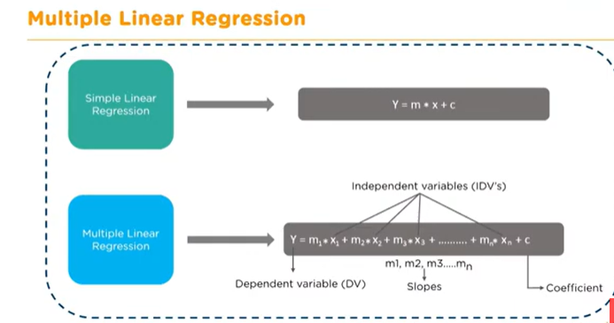
The code you've described is walking through a process to implement a Linear Regression model in Python. Here's a breakdown of what each part of the code does:
- Importing Libraries:
  - NumPy (np): Used for numerical computations.
  - Pandas (pd): A powerful library for data manipulation, especially for handling tabular data.
  - Matplotlib (plt) & Seaborn (sns): These libraries are used for visualizing the data, where Seaborn is built on top of Matplotlib and offers a more aesthetically pleasing interface for creating plots.
  - Inline Magic Command (%matplotlib inline): This ensures that plots appear within the Jupyter notebook.
- Loading and Inspecting Data:
  - The dataset (1000_companies.csv) is loaded using pd.read_csv() and stored in the variable companies.
  - x and y are set to the independent (features) and dependent (target) variables respectively. For example:
    - x contains all columns except the last one (R&D spend, administration, marketing, state).
    - y contains the last column (profit).
  - The head() method shows the first five rows of the data.
- Data Visualization:.
  - sns.heatmap(companies.corr())
  - Using Seaborn's pairplot(), the code visualizes relationships between different columns like R&D Spend, Administration, Marketing Spend, and Profit. This helps in understanding how the different variables correlate with each other.
  - sns.heatmap(companies.corr())
  - Preprocessing the Data:
  - Label Encoding: The 'State' column contains categorical values (e.g., 'New York', 'California', 'Florida'), which need to be transformed into numerical values. This is done using Label Encoding.
  - One-Hot Encoding: For the 'State' column, this transformation converts each unique category (state) into a binary column. One column for each state (e.g., New York, California, Florida) is created where the row will have a 1 if that state applies to the row, and 0 otherwise.

- Running Linear Regression:
  - After preprocessing the data, the next step would be splitting the data into training and testing sets, fitting a Linear Regression model, and making predictions.
  - The goal is to predict profit (y) based on the independent variables (x), which include R&D spending, administration costs, marketing spend, and the state of the company.
It looks like you're covering a detailed explanation of implementing multiple linear regression in a machine learning workflow. Here's a breakdown of the steps you're walking through:
- Avoiding the Dummy Variable Trap: You mentioned removing extra columns after using one-hot encoding to prevent redundancy in the model and avoid the dummy variable trap. This is crucial because including all dummy variables can lead to multicollinearity, where predictor variables are highly correlated with each other.
- Splitting the Data: You're using the train_test_split function from sklearn to divide the data into training and testing sets. You set the test_size to 0.2, which means 20% of the data will be held back for testing, ensuring the model is evaluated on unseen data.
- Creating the Linear Regression Model: After splitting the data, you use LinearRegression from sklearn to create and fit the model. The model learns from the training data (both the independent variables X_train and the dependent variable y_train).
- Making Predictions: After fitting the model, you predict the profit (or dependent variable) for the test data (X_test). This allows you to assess how well the model performs on unseen data.
- Calculating Coefficients and Intercepts: You access the regressor.coef_ and regressor.intercept_ to understand the learned parameters. These represent the slopes of the regression line and the intercept (constant) term in the equation of the model.
- Evaluating the Model with R²: The R² (R-squared) score is used to measure how well the model explains the variance in the dependent variable. A higher R² value indicates a better fit, with 1 being a perfect fit. An R² of 0.9352, as you mentioned, suggests that the model explains 93.52% of the variance in the dependent variable.
- Introduction to Logistic Regression: Finally, you introduce logistic regression, which is typically used for binary classification problems. The example you use is predicting whether a car will break down based on the number of years since its last service. The logistic function maps the probability of an event (e.g., a car breakdown) to a range between 0 and 1.
Logistic regression is a natural extension of linear regression for classification, using a sigmoid function to output probabilities. You also highlight how the number of years since the last service could influence the probability of a breakdown, providing a clear application of logistic regression.
You're providing a detailed explanation of logistic regression, its differences with linear regression, and its application in classification problems. Here's a summary of the key points:

Logistic Regression:
- Discrete Outcome: Logistic regression is used when the dependent variable (Y) is discrete (i.e., binary or categorical), such as predicting whether a car will break down (yes/no) or if an employee will get a promotion (yes/no). Unlike linear regression, which predicts continuous values, logistic regression is used for classification.
- Thresholding: Logistic regression calculates the probability of an event occurring. Since probabilities are continuous (between 0 and 1), a threshold is used to classify the outcome. For example:
  - If the probability is above 0.5, the outcome is classified as 1 (event happens).
  - If the probability is below 0.5, the outcome is classified as 0 (event does not happen).
- S-shaped Logistic Curve: The logistic regression model is represented by the sigmoid curve (an S-shaped curve), which models probabilities. This curve outputs values between 0 and 1, which makes it suitable for binary classification.
- Odds and Log-Odds: The odds of an event occurring is the ratio of the probability of the event happening to the probability of the event not happening. The log-odds is the logarithm of this ratio. The logistic regression model uses this transformation, and the equation is:
p(x)=11+e−(β0+β1x)p(x) = \frac{1}{1 + e^{-(\beta_0 + \beta_1 x)}}p(x)=1+e−(β0​+β1​x)1​
This equation is derived from the log-odds and represents the sigmoid function.
- Logistic Regression vs. Linear Regression:
  - Linear Regression: Predicts continuous outcomes. The model assumes a straight-line relationship between input features and the output. It's suitable for problems like predicting salary, stock prices, or house prices.
  - Logistic Regression: Predicts discrete outcomes. It's suitable for classification problems, such as predicting whether an event will happen or not (e.g., will it rain tomorrow, will a customer churn, etc.).

Key Differences:
- Output Type: Linear regression predicts continuous values, while logistic regression predicts probabilities for binary or categorical outcomes.
- Mathematical Representation: Linear regression uses a straight line equation y=β0+β1xy = \beta_0 + \beta_1 xy=β0​+β1​x, whereas logistic regression uses the sigmoid function.
- Curve Type: Linear regression produces a straight line, while logistic regression produces an S-shaped curve.
- 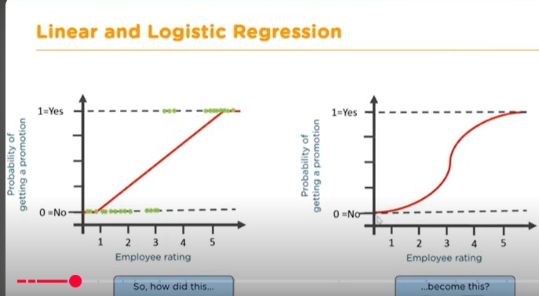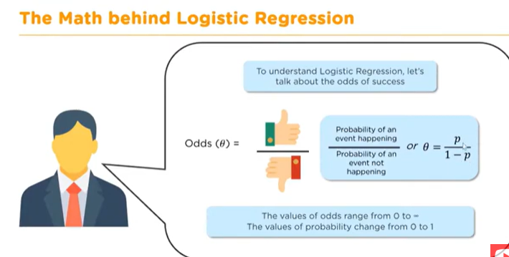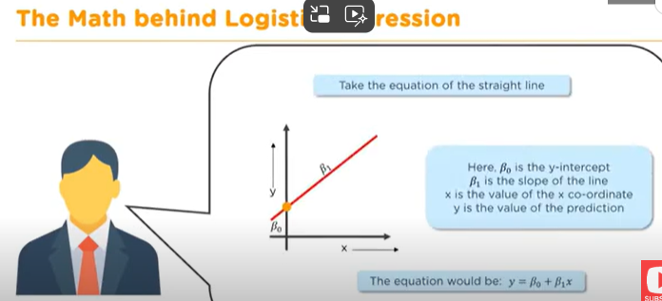
- 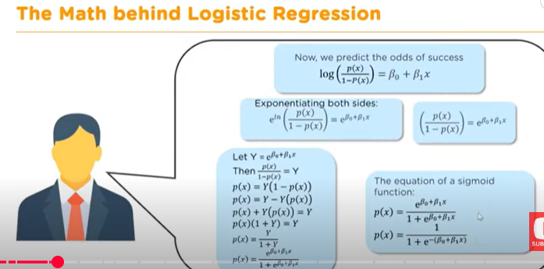

Practical Examples:
- Salary Prediction: Linear regression can be used to predict an employee's salary based on their experience, education, etc.
- Promotion Prediction: Logistic regression can be used to predict whether an employee will get a promotion (yes/no) based on their performance rating.
- Weather Prediction: Logistic regression is used for binary classification, such as predicting whether it will rain or not (yes/no). Linear regression could be used to predict continuous outcomes like tomorrow's temperature.

Multi-Class Classification:
- Logistic regression, in its basic form, is used for binary classification, but it can be extended to multi-class classification using techniques like One-vs-Rest (OvR) or Softmax Regression, which is often referred to as multinomial logistic regression. In multi-class classification, logistic regression can classify an instance into one of several possible classes (e.g., dog, cat, elephant).

1hr done

This transcript explains logistic regression, its application in binary and multiclass classification, and a practical implementation using Python with a digit recognition dataset. Below is a summary and key highlights:

Overview of Logistic Regression:
- Binary Classification: Determines whether a condition (e.g., is it a cat or not?) is true or false.
- Multiclass Classification: Logistic regression can extend to handle multiple classes (e.g., recognizing digits 0-9).
- Applications: Commonly used in healthcare (e.g., survival rate prediction) and object classification tasks.

Implementation Steps:
- Dataset Preparation:
  - Images are 8x8 grayscale pixels representing digits (0-9).
  - Each pixel's activation represents its intensity (a feature for the model).
- Data Splitting:
  - Use train_test_split to split data into training (77%) and testing (23%) datasets.
  - Labels (y_train, y_test) indicate the correct digit.
- Model Training:
  - Use Scikit-learn's LogisticRegression to fit the training data (X_train, y_train).
- Model Evaluation:
  - Predict on the test set using the .predict() method.
  - Calculate accuracy using .score() (94% in this example).
  - Generate a confusion matrix to visualize predictions vs. actual labels.

Confusion Matrix:
- Definition: A matrix that compares predicted and actual values.
- Structure:
  - Diagonal cells represent correct predictions.
  - Off-diagonal cells indicate misclassifications.
- Accuracy Calculation:
  - Accuracy=Sum of diagonal valuesTotal number of observations\text{Accuracy} = \frac{\text{Sum of diagonal values}}{\text{Total number of observations}}Accuracy=Total number of observationsSum of diagonal values​
- Heatmap Visualization: Colors emphasize the distribution of predictions.

Insights from Results:
- High Accuracy: Most values are on the diagonal.
- Sample Misclassifications: Observed where a number is mistaken for a visually similar digit (e.g., predicting 8 instead of 3).
- Improvement Areas: Enhance feature extraction, use regularization, or try advanced algorithms like Neural Networks.

Decision Trees:
Decision tree is a tree shaped diagram used to determine a course of action each branch of the tree represents a possible decision, occurrence or reaction
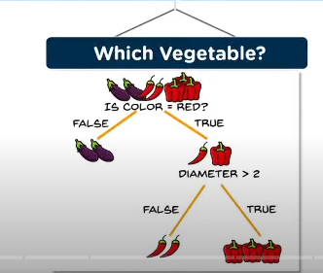
- An alternative method introduced briefly:
  - Classification: Solves yes/no type problems.
  - Regression: Handles continuous target variables.
  - Example: Identifying vegetables based on features like color and size.
This video/audio seems to provide an in-depth explanation of decision trees, including their advantages, disadvantages, and practical implementation in Python. Let me summarize the key points and clarify anything you might find challenging:

1. Decision Trees Overview
- Advantages:
  - Simple to understand, interpret, and visualize.
  - Requires minimal data preparation.
  - Handles both numerical and categorical data.
  - Robust to non-linear parameters.
- Disadvantages:
  - Overfitting: Tends to capture noise and may not generalize well.
  - High Variance: Sensitive to small data variations.
  - Low Bias: Complex trees can struggle with new data.

In machine learning, overfitting occurs when a model fits too closely to its training data, making it unable to make accurate predictions or conclusions about new data. This happens when a model trains for too long or is too complex, causing it to learn irrelevant information, or "noise", in the training data.
A good indicator of overfitting is low error rates and high variance. To prevent overfitting, a portion of the training dataset is usually set aside as a "test set" to check for it.

Bias in machine learning (ML) is a systematic error that occurs when a model's predictions are different from the actual outcomes. It can happen when a model makes assumptions or generalizations based on incomplete or limited data. This can lead to the model being skewed towards certain patterns or outcomes, which can result in unfair or discriminatory results.

2. Key Concepts
- Entropy: A measure of randomness or unpredictability in a dataset.
- Information Gain: The decrease in entropy after a split.
- Nodes:
  - Root Node: The starting point.
  - Decision Node: Splits data based on conditions.
  - Leaf Node: Represents a classification or final decision.

3. Implementation Steps in Python
- Import Libraries:
  - Essential libraries like numpy, pandas, and sklearn are used.
  - Specific modules: DecisionTreeClassifier and train_test_split.
- Load and Explore Data:
  - Load data (e.g., data2.csv) into a pandas DataFrame.
  - Check shape (data.shape), length (len(data)), and sample rows (data.head()).
- Prepare Data:
  - Divide the dataset into features (X) and the target variable (y).
  - Split into training and testing sets using train_test_split.
- Build and Train the Tree:
  - Use DecisionTreeClassifier to define the model.
  - Fit the model using training data (X_train, y_train).
- Visualize and Test:
  - Calculate accuracy using accuracy_score.
  - Optionally visualize the tree structure.

4. Additional Notes
- Entropy Calculation:
  - Formula: H=−∑i=1kp(i)⋅log⁡2(p(i))H = - \sum_{i=1}^{k} p(i) \cdot \log_2(p(i))H=−∑i=1k​p(i)⋅log2​(p(i))
  - Python handles this with inbuilt libraries.
- Overfitting Mitigation:
  - Limit tree depth or number of leaf nodes.
  - Use techniques like pruning or ensemble methods (e.g., Random Forest).
- Example Use Case:
  - Loan repayment prediction was discussed, using a dataset with customer information.

Would You Like Assistance With:
- Python code for this example?
- Exploring alternative classifiers or advanced techniques like ensemble methods?
- Handling issues with overfitting or improving model accuracy?
The passage provided is a transcript discussing decision trees, random forests, and support vector machines (SVMs) for classification problems in machine learning. Here's a concise breakdown of the key points:

Decision Trees
- Prediction: Using .predict() in scikit-learn to test a trained decision tree model with test data.
- Entropy: A measure of randomness or uncertainty in a dataset.
- Information Gain: A measure of the reduction in entropy after splitting the dataset.
- Nodes:
  - Root Node: The topmost node where the first split occurs.
  - Decision Nodes: Nodes that split the data further.
  - Leaf Nodes: The final nodes representing classifications or decisions.

Random Forests
- Why Use Random Forests?
  - Reduces overfitting.
  - Efficient for large datasets.
  - Handles missing data well.
- Mechanism: Combines decisions from multiple trees (majority vote) for robust predictions.

Support Vector Machines (SVM)
- Basic SVM:
  - Separates data points using a hyperplane.
  - Optimal hyperplane maximizes the margin (distance between support vectors and the hyperplane).
- Support Vectors: Data points closest to the hyperplane influencing its position.
- Kernel Trick:
  - Transforms non-linearly separable data into a higher-dimensional space to make it separable.
  - Example: Transforming overlapping 1D data into 2D for linear separation.

This overview highlights the importance of choosing the right algorithm and understanding the dataset's characteristics. If you'd like, I can explain any of these concepts in more detail or provide examples using Python code.

2nd Hour Done

The explanation provides an in-depth walkthrough of setting up and visualizing a Support Vector Machine (SVM) classifier using Python and its associated libraries. Here's a summary and key takeaways:

Key Concepts Discussed:
- High Dimensional Sparse Vectors:
  - SVM can handle sparse, high-dimensional spaces like document-token matrices with millions of tokens.
- Regularization Parameter (Lambda):
  - Balances bias and overfitting. SVM inherently handles this well, making it robust for various datasets.
- Zoo Example (Alligator vs. Crocodile):
  - A fun analogy is used to explain classification based on features like size and snout width.
- Two-Line SVM Implementation:
The core SVM creation and fitting process involve just two lines of code using sklearn:
python
Copy code
clf = svm.SVC(kernel="linear", C=1)
clf.fit(X, y)

- Visualization with Matplotlib:
  - Scatter Plot:
    - Shows data points categorized into two classes.
  - Hyperplane and Support Vectors:
    - The hyperplane maximizes the margin between classes, visualized as a solid line.
    - Support vectors are the closest data points to the hyperplane, displayed as dashed lines.
- Data Creation:
  - Used make_blobs to generate synthetic data, eliminating the need for real-world measurements.
- Grid Creation and Prediction:
  - Used np.meshgrid to create a grid of points for visualization.
  - The decision_function calculates the distance of each point from the hyperplane.
- Graphical Output:
  - The final plot clearly illustrates the two classes, the hyperplane, and the support vectors.

Why This Example Works Well:
- Engaging Analogy: The zoo example simplifies the understanding of classification problems.
- Comprehensive Visualization: The graph provides a tangible representation of abstract SVM concepts.
- Step-by-Step Breakdown: Details on both implementation and visualization make it accessible for learners.

Suggestions for Implementation:
If you're planning to replicate or enhance this setup:
- Extend to Multi-Class Classification:
  - Use decision_function_shape='ovo' for one-vs-one or ='ovr' for one-vs-rest multi-class setups.
- Experiment with Non-Linear Kernels:
  - Try poly, rbf, or sigmoid kernels for more complex datasets.
- Optimize Parameters:
  - Use techniques like Grid Search (GridSearchCV) to fine-tune C and kernel parameters.
- Add Real Data:
  - Transition from synthetic data to a real-world dataset for practical insights.
- Enhance Visualization:
  - Add interactive visualization with libraries like plotly for more dynamic outputs.
Would you like to see the complete code for any specific part or need help tailoring this to a particular dataset?
4o

This transcript provides a comprehensive explanation of the k-nearest neighbors (KNN) algorithm, from its theoretical basis to its practical implementation in Python. Here are the key highlights:

KNN Algorithm Basics
- Definition: KNN is a lazy learning algorithm that classifies a new data point based on similarity measures (e.g., Euclidean distance) with its neighbors in the dataset.
- Parameters:
  - k: The number of nearest neighbors to consider.
  - Similarity Measure: Typically Euclidean distance.
- Decision Making: Majority voting from k nearest neighbors determines the classification.

Choosing k
- A small k (e.g., 3) might lead to noise influencing the result, whereas a large k (e.g., 20) could dilute the local data context and increase computation time.
- Rule of Thumb:
  - Use the square root of the dataset size.
  - Adjust k to an odd number to avoid ties in voting.

When to Use KNN
- Appropriate Scenarios:
  - Data is labeled.
  - Dataset is small.
  - Noise-free or minimal noise data.
- Avoid:
  - Large datasets.
  - High dimensional or noisy data.
  - Scenarios requiring real-time processing (due to its computational cost).

Steps to Implement KNN in Python
- Load Data:
  - Use Pandas to load CSV files and explore the dataset.
  - Check for missing or invalid values.
- Preprocessing:
  - Replace invalid (e.g., zeros for glucose or blood pressure) or missing values with the mean of respective columns.
  - Scale features using a standard scaler to normalize values between -1 and 1.
- Split Data:
  - Use train_test_split to divide the dataset into training and testing sets.
- Train and Evaluate:
  - Train the KNN model using KNeighborsClassifier from Scikit-learn.
  - Evaluate the model using confusion matrix, F1-score, and accuracy.

Practical Use Case: Predicting Diabetes
- Dataset: A CSV file with attributes like glucose, blood pressure, and outcome (diabetes diagnosis).
- Steps:
  - Handle missing or zero values by replacing them with column means.
  - Scale features using StandardScaler.
  - Split the dataset (e.g., 80% for training, 20% for testing).
  - Use KNN to predict whether a person has diabetes based on the majority vote of k neighbors.

Code Implementation
The transcript walks through code implementation in a Jupyter Notebook, highlighting:
- Imports:
  - General libraries: Pandas, NumPy.
  - Machine learning: Scikit-learn modules for preprocessing, training, and evaluation.
- Dataset Handling:
  - Loading and inspecting the data.
  - Replacing zero values.
  - Normalizing features with StandardScaler.
- Training and Testing:
  - Fitting the model with training data.
  - Testing and evaluating performance using metrics.
it represents the variance or spread within a single large cluster. As we increase the value of kkk (number of clusters), the WSS decreases because the data points are divided into smaller and more compact clusters. However, after a certain point, the decrease in WSS becomes minimal, and the graph forms an "elbow."
The "elbow point" is where the rate of decrease slows down significantly, indicating the optimal number of clusters. This is the point at which adding more clusters does not significantly improve the compactness of the clusters and represents the best trade-off between simplicity and accuracy.

Summary of Key Concepts:
- K-Nearest Neighbors (KNN):
  - A supervised learning algorithm.
  - Used for classification by considering the kkk-nearest data points.
  - Evaluated using confusion matrices, F1 scores, and accuracy.
- K-Means Clustering:
  - An unsupervised learning algorithm.
  - Groups data points into kkk clusters based on similarity.
  - Distance measures like Euclidean and Manhattan distances determine cluster assignment.
  - The algorithm iteratively updates centroids until convergence (no further movement).
- Elbow Method:
  - A technique to determine the optimal kkk value.
  - Plots WSS against the number of clusters.
  - The "elbow" point is chosen as the optimal number of clusters.
Both KNN and K-Means are foundational machine learning techniques with applications in classification, clustering, and decision-making across diverse domains. If you need further clarification or a code example for implementation, feel free to ask!

3rd hour done
This transcription captures a thorough explanation of K-means clustering, including its steps, implementation, and real-world applications, particularly with a Python example. Here’s a concise breakdown and key points:

Key Concepts:
- Elbow Method:
  - The Elbow Method is used to determine the optimal number of clusters (kkk).
  - Plot kkk vs. within-cluster sum of squares (WSS). The "elbow point" indicates a significant drop in WSS, signifying the optimal kkk.
- K-means Algorithm Steps:
  - Initialization: Randomly assign kkk centroids.
  - Assignment: Assign each data point to the nearest centroid.
  - Centroid Update: Recalculate the centroids as the mean of assigned points.
  - Iteration: Repeat the assignment and update steps until centroids no longer change (convergence).
- Implementation:
  - Use Python libraries like scikit-learn for K-means clustering.
  - Alternatively, a manual implementation involves:
    - Distance calculations.
    - Reassigning data points based on proximity.
    - Iteratively recalculating centroids until convergence.
- Application Example:
  - Walmart Store Placement:
    - Use customer location data to find optimal store locations.
    - Avoid over-concentration or excessive dispersion of stores.
  - Steps:
    - Generate test data with make_blobs in scikit-learn.
    - Visualize data to estimate clusters.
    - Apply K-means to identify centroids (optimal store locations).
- Python Code Explanation:
  - Library Import: Include numpy, matplotlib, and scikit-learn.
  - Blob Creation: Use make_blobs for synthetic data.
  - K-means Model: Use KMeans from scikit-learn, specify n_clusters, and call .fit() and .predict() methods.
- Custom Implementation:
  - Randomly initialize centroids.
  - Calculate distances using a distance metric (e.g., Euclidean).
  - Assign points to the closest centroid.
  - Update centroids based on current group assignments.
  - Stop iterating when centroids stabilize.

Additional Insights:
- Distance Calculation:
  - The distance between data points and centroids is critical for point assignment and centroid updates.
- Convergence:
  - The algorithm converges when centroid positions no longer change.
- Visualization:
  - Scatter plots effectively show cluster formations and centroid placements.
This content extensively covers the implementation and application of K-means clustering and introduces data types and mathematical foundations for machine learning. Here's a structured summary and analysis:

1. K-Means Clustering:

Basic Implementation:
- Centroid Convergence:
  - Basic logic assumes strict equality for centroid convergence.
  - Could include a tolerance level (e.g., a centroid shift of < 0.001) for efficiency.
- Output Visualization:
  - Data points clustered with centroids marked.
  - A simple demonstration using a dataset and clustering into 4 groups.

Applications:
- Color Compression:
  - Used to reduce millions of colors in images to a manageable number (e.g., 16).
  - Workflow:
    - Import and reshape image data.
    - Normalize pixel values (0-255 to 0-1).
    - Apply MiniBatchKMeans (efficient for large datasets).
    - Replace pixel values with cluster centroids.
  - Result: Compressed images retain key features but with reduced quality.

Key Observations:
- Quality trade-offs between the original and compressed images.
- MiniBatchKMeans improves performance on large datasets while maintaining clustering quality.

2. Mathematics for Machine Learning:

Data Types:
- Qualitative (Categorical):
  - Nominal: Labels without order (e.g., gender, country).
  - Ordinal: Categorical with order (e.g., salary ranges, ratings).
- Quantitative (Numerical):
  - Discrete: Finite values (e.g., questions answered correctly).
  - Continuous: Infinite possible values within a range (e.g., weight, stock prices).

Linear Algebra:
- Linear Equations:
  - Maximum order = 1 (e.g., ax+b=cax + b = cax+b=c).
  - Basis for neural networks and regression models.
- Vectors & Matrices:
  - Represent systems of equations, transformations, or data structures.
  - Used in numerous ML algorithms for computations like dot products, eigenvalues, etc.

Key Formula:
- y=mx+cy = mx + cy=mx+c: Foundational linear equation.
  - mmm: Slope.
  - ccc: Intercept.

Suggestions for Improvement or Exploration:
- K-Means Clustering:
  - Integrate silhouette scores or elbow methods to determine optimal kkk.
  - Compare with hierarchical clustering or DBSCAN for non-linear separations.
- Mathematics for ML:
  - Dive deeper into matrix operations (e.g., eigenvalues, singular value decomposition).
  - Apply these concepts to principal component analysis (PCA) for dimensionality reduction.

Key Concepts in Linear Algebra:
- Equations of a Line:
  - Formula: y=mx+cy = mx + cy=mx+c where mmm is the slope and ccc is the y-intercept.
  - Slope (gradient) significance: Determines the steepness and direction of a line.
- Matrix Basics:
  - Defined as a rectangular array of numbers arranged in rows (mmm) and columns (nnn).
  - Example notation: aija_{ij}aij​ denotes the element in row iii and column jjj.
- Matrix Operations:
  - Addition/Subtraction: Performed element-wise if matrices have the same dimensions.
  - Multiplication: Uses the dot product rule for combining rows of one matrix with columns of another.
  - Transpose: Flips a matrix along its diagonal.
  - Inverse: A matrix that satisfies A⋅A−1=IA \cdot A^{-1} = IA⋅A−1=I, where III is the identity matrix.
- Vectors:
  - One-dimensional matrices with magnitude and direction.
  - Used in nnn-dimensional space to represent points and directions.
- Key Matrix Concepts:
  - Dot Product: Simplifies computations in linear equations and vector alignment.
  - Eigenvalues and Eigenvectors:
    - Eigenvalues scale a vector.
    - Eigenvectors remain invariant in their direction during transformations.
  - Identity Matrix: A diagonal matrix used for comparisons or transformations.
- Practical Applications:
  - Scalar multiplication and vector addition/subtraction.
  - Matrix-vector multiplication for transformations.
  - Usage in systems of linear equations and feature comparison.

Linear Algebra in Machine Learning:
- Used extensively in:
  - Data transformations: Scaling, rotating, or skewing datasets.
  - Optimization algorithms: Matrix operations simplify solving systems of equations.
  - Principal Component Analysis (PCA): Dimensionality reduction via eigenvalues/eigenvectors.

Python Implementation Using NumPy:
- Matrix Creation and Operations:
  - numpy.array() for defining matrices.
  - Functions like numpy.dot(), numpy.transpose(), and numpy.linalg.inv() for dot product, transpose, and inverse operations.
- Applications:
  - Efficient computations for regression models (e.g., linear regression).
  - Preprocessing data for machine learning pipelines.
  - Basis for neural network operations.

Intersection with Calculus:
- Gradient Descent:
  - Optimization method relying on partial derivatives to minimize cost functions.
- Differential Equations:
  - Essential for understanding and implementing complex machine learning algorithms, especially in deep learning.

Takeaway for Data Scientists:
Understanding linear algebra's fundamentals provides the foundation for:
- Designing machine learning models.
- Interpreting matrix transformations.
- Debugging and optimizing workflows involving complex mathematical operations.

4th hour done
The transcript you've provided dives into various concepts of calculus and its applications, particularly in machine learning, along with an introduction to statistics. Below is a concise breakdown and explanation of key points to make them more accessible:

Calculus Concepts and Applications
- Rate of Change:
  - Calculus helps compute instantaneous rates of change. For example, the slope of a curve representing speed vs. time gives acceleration.
  - This involves concepts like limits and derivatives to find precise rates over infinitesimally small intervals.
- Integration:
  - Integration sums up these small changes, calculating total change or areas under curves.
  - Example: Finding total acceleration over time involves integrating acceleration data.
- Multivariate Calculus:
  - Deals with functions of multiple variables. Essential in understanding how changes in one variable affect others.
  - Key for neural networks where layer outputs depend on changes from previous layers.
- Gradient Descent:
  - An optimization technique to minimize (or maximize) error in models by iteratively adjusting variables.
  - Uses derivatives to find the slope, stepping toward the function’s minimum (or maximum).
  - Key parameters:
    - Learning Rate: Determines step size.
    - Precision: Stopping criterion based on the smallest acceptable change.

Gradient Descent Code Breakdown
The provided Python script implements gradient descent:
python
Copy code
current_x = 3 # Starting point
learning_rate = 0.1
precision = 0.0001
max_iters = 1000
previous_step_size = 1
iters = 0
derivative = lambda x: 2 * x + 5

while previous_step_size > precision and iters < max_iters:
prev_x = current_x
current_x -= learning_rate * derivative(prev_x)
previous_step_size = abs(current_x - prev_x)
iters += 1

print(f"Local minimum occurs at: {current_x}")

- Key insights:
  - It calculates the derivative to adjust x iteratively.
  - Stops based on precision or maximum iterations.

Statistics Overview
- Key Concepts:
  - Population: Entire set of entities or objects being studied.
  - Sample: A subset of the population.
  - Parameter: Characteristics or measures of a population.
  - Variable: Measurable characteristic of entities in the population.
- Sampling Methods:
  - Probabilistic Sampling:
    - Random Sampling: Purely random selection.
    - Systematic Sampling: Selecting at regular intervals.
    - Stratified Sampling: Sampling from distinct groups for representation.
  - Non-Probabilistic Sampling:
    - Based on convenience or researcher judgment but prone to bias.
- Descriptive vs. Inferential Statistics:
  - Descriptive: Summarizes data (e.g., mean, median, mode).
  - Inferential: Makes predictions or generalizations based on sample data.

Takeaways for Machine Learning
- Calculus forms the foundation of key machine learning processes like optimization and backpropagation.
- Gradient descent, informed by derivatives and multivariate calculus, drives parameter tuning.
- Statistics supports data analysis, sampling, and evaluation of model performance.
If you'd like, I can extract specific parts, provide further clarification, or assist with implementing any related code!
The section you're referring to dives into both descriptive and inferential statistics. Here's a breakdown of the key concepts discussed:

Descriptive Statistics
These statistics are used to summarize or describe the basic features of a dataset. They help convey the general characteristics of the data through measures such as:
- Central Tendency: This includes the mean (average), median (middle value), and mode (most frequent value).
  - Mean: Calculated by summing all the data points and dividing by the total number.
  - Median: The middle value when the data is sorted.
  - Mode: The most frequently occurring value.
- Spread/Dispersion: Describes how data is spread out. Measures include:
  - Range: The difference between the highest and lowest values.
  - Interquartile Range (IQR): The range within which the middle 50% of the data falls (between the first and third quartiles).
  - Variance: Measures how far each value in the dataset is from the mean.
  - Standard Deviation: The square root of the variance, providing a measure of spread in the same units as the data.

Inferential Statistics
This branch is used to make predictions or inferences about a larger population based on a sample of data. It goes beyond description and helps in generalizing results.
- Point Estimation: A process of estimating population parameters (like mean) based on sample data. For example, testing vaccine effectiveness by extrapolating results from a small group to the general population.
- Hypothesis Testing: A statistical method used to determine the plausibility of a hypothesis about a population based on sample data. The steps involve:
  - Formulating the hypothesis.
  - Choosing the appropriate statistical test.
  - Performing the test.
  - Making a decision (whether to reject or fail to reject the hypothesis).
In the case of the example with students picking chits to clean a room, you would use probability and inferential statistics to assess whether there's any bias or mischief (like Rob rigging the draw), based on the observed outcomes over several days.
This introduction to statistical concepts is foundational for understanding how we analyze data to make decisions, whether in economics, healthcare, or other fields. Would you like to dive deeper into any specific area, such as hypothesis testing or probability?
This section of the text discusses various statistical concepts and terminologies that are essential for understanding hypothesis testing, probability theory, and data analysis.
- Null and Alternative Hypothesis:
  - Null hypothesis (H₀): It posits that there is no relationship between two variables, i.e., no effect. It suggests that any observed differences are due to random chance.
  - Alternative hypothesis (H₁): This contradicts the null hypothesis, suggesting that a significant relationship or effect exists between the variables.
- P-value and T-value:
  - P-value: It represents the probability of observing the results, or more extreme outcomes, given that the null hypothesis is true. A p-value lower than 0.05 (typically) suggests rejecting the null hypothesis.
  - T-value: A statistic used in hypothesis testing, measuring the size of the difference relative to the variation in the sample data. Larger T-values indicate stronger evidence against the null hypothesis.
- Confidence Interval:
  - It provides a range of values within which we expect the true population parameter (e.g., average) to lie. For example, if 95% of the sample data falls between 200 and 300, we can confidently say the true value lies within this range with 95% certainty.
- Probability:
  - Probability is the likelihood of an event happening. It ranges between 0 (impossible) and 1 (certain). For example, a coin toss has a 50% probability for heads or tails.
  - Random variables are outcomes that can take on various values based on random phenomena, such as the outcome of a dice roll.
- Binomial Distribution:
  - A distribution used when there are exactly two outcomes (e.g., success or failure) in multiple trials. The probability of success and failure is constant for each trial. For example, in a football game, the probability of a team winning or losing a match can be modeled using a binomial distribution.
- Z-score:
  - A Z-score indicates how many standard deviations a data point is from the mean. It's useful for identifying outliers. A high Z-score means the data point is far from the mean, whereas a Z-score close to 0 indicates the data is near the mean.
- Central Limit Theorem:
  - This theorem states that the distribution of the sample mean will approximate a normal distribution as the sample size grows, regardless of the shape of the original population distribution.
- Bayes' Theorem:
  - A key theorem in probability, it describes the likelihood of an event based on prior knowledge of conditions related to the event. It’s used to update the probability estimate for an event as more evidence is acquired. For example, given the prior probability of smoking and lung disease, Bayes' theorem can help calculate the likelihood that a smoker will develop lung disease.
- Python Code Example:
  - The discussion includes coding examples using Python to demonstrate the implementation of concepts like sets, random variables, and calculating the probabilities of dice outcomes using the product of sets.
The lecture emphasizes the importance of understanding these concepts in data science and statistics, as they are foundational for analyzing and interpreting data correctly.

5th Hour done
It looks like you’re working through a detailed example of probability calculations, confusion matrices, and machine learning concepts. Here's a breakdown of the key elements you covered:
- Dice Probabilities:
  - You showed how to calculate probabilities with two dice, including the case for sums that are multiples of 3 and multiples of 5, excluding multiples of 3.
  - This demonstrated the process of calculating probabilities by dividing favorable outcomes by the total possible outcomes. You worked with 2 dice and later 5 dice, handling large datasets for complex probability calculations.
- Confusion Matrix:
  - You explained the confusion matrix, which is crucial for evaluating classification models. The matrix includes:
    - True Positives (TP): Correctly predicted positive outcomes.
    - False Positives (FP): Incorrectly predicted as positive.
    - False Negatives (FN): Incorrectly predicted as negative.
    - True Negatives (TN): Correctly predicted negative outcomes.
  - The confusion matrix helps calculate key metrics like accuracy, precision, and recall.
- Naive Bayes Classifier:
  - You introduced the Naive Bayes classifier, particularly focusing on the Gaussian Naive Bayes method. This classifier assumes that the features are independent given the class label, and it is often used for binary classification tasks.
  - You worked with a dataset related to social network ads, containing information such as age, salary, and whether a user made a purchase or not.
  - You showed how to pre-process the data (splitting into training and test sets, scaling features), fit the Naive Bayes model, and evaluate its performance using the confusion matrix.
  - You also covered how to visualize the decision boundary using a contour plot, which illustrates the classifier’s decision regions for different classes (purchase vs. no purchase).
This is a solid approach to understand both theoretical concepts and their practical application with real-world data. Let me know if you need any further clarification or examples!
4o mini
The content you've provided covers various concepts related to machine learning, specifically focusing on supervised, unsupervised, and reinforcement learning. Here's a brief summary and explanation of key points:
- Classification Metrics (Precision, Recall, Accuracy):
  - The importance of evaluating machine learning models using metrics like precision, recall, and F1-score is highlighted. Precision measures how many predicted positives are actually correct, while recall shows how many true positives were correctly identified. Accuracy evaluates the overall correctness of the model.
- Reinforcement Learning Overview:
  - Reinforcement learning (RL) is a branch of machine learning where an agent learns to make decisions by interacting with its environment and receiving feedback (rewards or penalties). The agent explores actions and learns to maximize its rewards through trial and error.
  - The agent, environment, action, state, reward, and policy are key components of RL. These terms form the foundation of how RL models are structured and operate.
- Supervised vs Unsupervised vs Reinforcement Learning:
  - Supervised Learning involves using labeled data to train models (e.g., classification or regression). The model learns the mapping from input to output based on known labels.
  - Unsupervised Learning deals with unlabeled data and aims to find hidden patterns or structures, such as clustering or association.
  - Reinforcement Learning is reward-based, where the agent learns by interacting with the environment and receiving feedback. It’s used for problems where the solution is not obvious and the agent must explore different actions to find the best strategy.
- Markov Decision Process (MDP):
  - MDPs are used to formalize decision-making in reinforcement learning. They model the agent's interactions with the environment, where the agent takes actions based on the current state and receives rewards, aiming to maximize its total rewards over time.
- Tic-Tac-Toe Example for Reinforcement Learning:
  - A practical reinforcement learning example is training a model to play Tic-Tac-Toe. The agent learns by trying different actions (moves), receiving rewards (e.g., winning a game), and refining its strategy over time.
The text also includes details about implementing reinforcement learning using Python, with a class-based approach to represent the state of the game board and actions taken by the agent, focusing on reward systems and decision-making. Would you like to delve deeper into any specific part of this content?
This explanation focuses on reinforcement learning (RL) in the context of a Tic-Tac-Toe game, emphasizing key aspects like reward systems, state transitions, and action selection.
- Reward System: In RL, the agent receives feedback after taking an action. Rewards help guide the agent to find optimal strategies. For example, in Tic-Tac-Toe, a reward might be given when a move is valid (like 0.1 or 0.5) or when the game is won (like 10 points). The agent uses these rewards to adjust its decision-making process over time.
- Action Selection: The agent's action is crucial in RL. Actions are chosen based on the current state of the environment (the board in this case). The strategy may include randomness to explore different possibilities. Eventually, the agent should learn the best actions that maximize rewards. In more complex scenarios, actions may involve large neural networks that require substantial computational resources to train.
- Training Process: The agent improves by playing against itself (or another agent) through trial and error. The more games it plays, the more it refines its decision-making. This process is computationally intensive, especially in complex environments. It’s crucial to train the agent over many rounds, and during this training, rewards are adjusted (discounted using a factor like gamma) to emphasize later actions that lead to a win.
- Q-Learning: Q-learning is a specific type of RL where the agent learns a policy by estimating the value of each action at each state. The goal is to maximize cumulative reward over time by choosing actions that yield the highest expected reward. It is considered model-free because it doesn’t rely on a predefined model of the environment but rather learns from experience.
- Challenges: While RL is powerful, its training process can be time-consuming, especially in complex environments with large state spaces. As shown in the Tic-Tac-Toe example, training the agent for even a few rounds takes time, and for large problems, this can become impractical. However, with advances in algorithms and computational power, RL is expected to become more efficient and applicable to a broader range of problems.
In summary, RL teaches an agent to optimize actions by interacting with its environment and receiving rewards, allowing it to solve problems like games, navigation tasks, or even real-world applications such as language translation or robotics.

6th Hour done
It seems like you're working through a Q-learning example that highlights its potential in applications like product recommendations, specifically using the context of ad recommendations based on previous user actions (clicks). Here’s a breakdown of the core concepts and steps you're exploring:

Key Concepts:
- States: Represent the current situation or position of an agent in the environment (e.g., the webpage a user is on, or the type of ad currently displayed).
- Actions: The steps an agent can take from a given state, such as displaying a specific ad or suggesting a related product.
- Rewards: Positive or negative feedback resulting from an action, like a user clicking on an ad. The objective is to maximize these rewards by choosing the best actions.
- Episodes: The sequence of steps an agent takes from start to finish until it reaches a terminal state (e.g., the user stops browsing or makes a purchase).
- Q-value: A value used to represent the "goodness" of an action taken in a given state. It is updated using the Bellman equation, factoring in rewards and expected future rewards.
- Bellman Equation: A fundamental equation used in Q-learning to update Q-values, balancing current rewards and the expected future rewards.
- Temporal Difference: A method used to update Q-values by considering the current and previous states and actions.
- Learning Rate (α): Determines how much new information overrides old information. A high learning rate can make the model adapt quickly, but potentially with instability.
- Discount Rate (γ): Represents the importance of future rewards. A value closer to 1 puts more emphasis on future rewards.

Q-Learning Process for Ad Recommendations:
- Initialization: Start by creating a Q-table with initial values set to zero. This table tracks the value (or "reward") of each state-action pair.
- Exploration: Select actions randomly to explore the environment (product ads) and gather rewards based on user interactions (clicking ads).
- Update Q-values: After each action, update the Q-table using the Bellman equation to adjust the expected value of future actions based on received rewards.
- Iteration: Continue iterating and refining the Q-values by repeating the process for multiple episodes (user interactions), gradually learning which ads are more likely to generate clicks.

Example Use in Product Recommendations:
- State: Current user's browsing behavior or previously clicked product.
- Action: Suggesting an ad for a related product.
- Reward: User clicking on the suggested ad (positive reward) or ignoring it (negative reward).
This approach helps an ad recommendation system learn from user behaviors over time and adapt to suggest the most relevant products, maximizing the chance of user interaction.

You can continue this process by defining your Q-table and iterating through the system, adjusting actions (ads) based on observed rewards, ultimately improving your ad recommendation algorithm.
Let me know if you'd like a more specific implementation guide or further details!
This passage describes the process of dimensionality reduction using Principal Component Analysis (PCA) and its applications, specifically in a dataset involving cancer data. Here are the key points:

Dimensionality Reduction and PCA
- Dimensionality reduction is crucial to simplify complex datasets, which can help improve computational efficiency, reduce redundancy, and make data easier to interpret. By reducing the number of dimensions (attributes or features), models can become more efficient.
- Principal Component Analysis (PCA) is a technique for reducing the dimensionality of data while retaining as much information as possible. PCA transforms the original features into a new set of variables called principal components that are linear combinations of the original variables.
- The principal components are orthogonal (independent) to each other, and each subsequent component captures the greatest variance in the data while being orthogonal to previous components.

Key Steps in PCA
- Standardization: Normalize the dataset by removing the mean and scaling the variables so that they have comparable scales.
- Covariance Matrix Computation: Calculate how the variables correlate with each other.
- Eigenvectors and Eigenvalues: Determine the directions (eigenvectors) and magnitudes (eigenvalues) that explain the variance in the dataset.
- Feature Vector: Construct a matrix of the principal components that we want to keep based on the eigenvectors.

PCA Terminologies
- Views: Different perspectives or angles from which data points are observed in PCA.
- Dimensions: Refers to the number of features or columns in the dataset.
- Principal Component: A linear combination of the original features that captures the maximum variance.
- Projections: The perpendicular distance between data points and their corresponding principal components.

PCA Properties
- The number of principal components is always less than or equal to the number of features.
- Principal components are orthogonal to each other.
- As you move from the first to higher principal components, their explanatory power (how much variance they capture) decreases.

Application Example (Cancer Dataset)
- The passage also includes a practical example using a cancer dataset with 35-36 features. The dataset includes various measurements of cells in a cancerous tumor, with the target being whether the tumor is malignant or benign.
- In the example, PCA is applied to reduce the dimensionality and visualize the data.

Hands-On Demo
- The tutorial proceeds to set up Python libraries (like matplotlib, numpy, and pandas) and load the cancer dataset to perform PCA. The goal is to simplify the dataset and understand how the data points can be projected onto principal components for better analysis.
Let me know if you want further explanation on any specific section or the code involved!
It seems like you're discussing a data science workflow, particularly focusing on principal component analysis (PCA), dimensionality reduction, and linear regression, with an emphasis on bias, variance, overfitting, and underfitting. Here's a breakdown of the concepts:
- PCA and Dimensionality Reduction:
  - You first scale your data and use PCA to reduce the dimensions. PCA helps in visualizing high-dimensional data by transforming it into principal components. In this case, you're reducing the data from 30 features to 2 principal components, which makes it easier to plot and analyze.
  - After applying PCA, you can visualize the data in a 2D scatter plot to observe how well the two components separate the different classes (malignant vs benign).
- Interpreting PCA Components:
  - PCA doesn't provide a direct interpretation of what each component represents. However, by looking at the component loadings (which show the relationship between the original features and the principal components), you can infer the importance of each feature in forming the components. The heatmap of component weights is a useful tool here to visualize the correlations between features and components.
- Bias and Variance:
  - Bias refers to the error introduced by overly simplistic models that fail to capture the underlying patterns in the data, resulting in a poor fit both on training and test sets.
  - Variance refers to the error introduced by models that are too complex and fit the training data too well, including noise, which leads to poor performance on new, unseen data.
  - Bias-variance tradeoff: A good model should balance bias and variance. High bias leads to underfitting, where the model cannot capture the data’s patterns. High variance leads to overfitting, where the model fits noise in the data.
- Overfitting:
  - Overfitting occurs when a model learns not only the true patterns but also the noise in the training data. This results in poor generalization to new data.
  - It’s important to ensure that the model doesn’t just memorize the training data but can generalize well to unseen data.
- Fitting the Data:
  - Linear Regression: In linear regression, a line (or hyperplane in higher dimensions) is drawn to best fit the data points. The goal is to minimize the error (mean squared error, or MSE) between the predicted values and the actual data.
  - In your example, the best-fit line is determined by minimizing the MSE, and the goal is to find the line that has the least error in predicting the outcome.
This is a common process in data science to understand the relationship between variables, reduce dimensionality for easier analysis, and build models that can generalize well to new data.

7th Hour Done

This excerpt covers several key concepts in machine learning, particularly related to model fitting, regularization techniques, and the importance of feature selection. Here’s a summary of the main points discussed:
- Overfitting and Underfitting:
  - Overfitting occurs when a model is too complex and fits the training data too closely, including noise, leading to poor performance on new data.
  - Underfitting happens when the model is too simple and does not capture the patterns in the data, resulting in poor predictions for both training and test data.
  - Solutions for both issues often include cleaning the data, ensuring sufficient data size, and adjusting the model’s complexity.
- Good Fit:
  - A good model is one that balances bias and variance, fitting the data well without overfitting or underfitting. A good fit typically minimizes errors and generalizes well to new data.
- Regularization:
  - Regularization techniques such as Ridge Regression and Lasso Regression help manage overfitting and underfitting by adding penalties to the model, discouraging overly complex models.
    - Ridge Regression: Adds a penalty equivalent to the sum of the squared coefficients. It’s effective when you have many variables with relatively smaller data samples.
    - Lasso Regression: Adds a penalty using the absolute values of the coefficients, which can drive some coefficients to zero, helping with feature selection and regularization.
- Feature Selection:
  - The need for feature selection arises when working with large datasets, as including irrelevant or redundant features can degrade model performance. Feature selection helps identify the most important variables to train the model effectively, potentially improving its accuracy and reducing complexity.
- Practical Application:
  - The presenter discusses how to implement Ridge and Lasso Regression using Python’s scikit-learn, including splitting the dataset into training and test sets, training the models, and evaluating them using metrics like mean squared error (MSE).
  - They also demonstrate how to compare the coefficients of different models and visualize them, noting that Ridge regression tends to reduce the magnitude of coefficients, while Lasso regression can eliminate some coefficients altogether.
This provides a thorough overview of how regularization can be applied to improve model performance, alongside the importance of selecting relevant features and evaluating the model’s fit through metrics and visualizations.
4o mini
In this detailed breakdown, the speaker emphasizes the importance of feature selection in building efficient and effective machine learning models. Here are the key points covered:
- Feature Selection: The main goal of feature selection is to reduce the complexity of the model by keeping only the relevant features and eliminating irrelevant or redundant ones. By doing so, the model can focus on the most important data, improving accuracy and reducing overfitting.
- Drop Irrelevant Features: The example given about cars being crushed highlights how some features, such as the owner of the car, are not useful for the model's prediction (e.g., crushing a car is not dependent on its previous owner). Similarly, in the book donation example, features like color are unnecessary for the model.
- Methods of Feature Selection:
  - Filter Method: This approach drops features based on their correlation to the output. For example, irrelevant features such as the color of the book can be removed.
  - Wrapper Method: Features are selected by running models on subsets of data and evaluating their performance. The subset of features that gives the best result is kept.
  - Intrinsic Method: A combination of filter and wrapper methods, using algorithms like Lasso regression or decision trees to automatically select the most important features.
- Benefits of Feature Selection: By removing irrelevant features, models can be faster, less prone to overfitting, and more accurate. It also helps in reducing training time, which can grow exponentially with the addition of more features.
- Exploration of Feature Selection Using Python:
  - The example with basketball data (Kobe Bryant's game statistics) demonstrates the use of various feature selection techniques.
  - Visualizations like scatter plots help identify redundant data (e.g., latitude and longitude might be redundant when converted to distance and angle).
  - The speaker also explores combining related columns (e.g., minutes and seconds remaining) and dropping columns with duplicate or redundant data.
Overall, the discussion focuses on reducing the number of features to make the model more efficient, prevent bias, and improve its performance. The code shown utilizes Python libraries such as pandas, numpy, and matplotlib to perform feature selection and visualization.
It looks like you're working through a detailed process of performing sentiment analysis on Twitter data, particularly regarding the U.S. 2020 presidential election. You're using Python libraries like pandas, textblob, and wordcloud to analyze tweets, determine sentiment (positive, negative, or neutral), and visualize the results. Here's a summary of the steps you've covered:
- Data Collection: You've gathered 5,000 tweets each for Donald Trump and Joe Biden using the Twitter API. This data is stored in CSV files with tweet content and user details.
- Sentiment Analysis: You use the TextBlob library to analyze the polarity (positive/negative/neutral) and subjectivity of each tweet. The polarity is used to classify tweets as positive, negative, or neutral.
- Data Preprocessing:
  - You added a "polarity" column to both Trump and Biden data frames.
  - Based on polarity, you classified tweets as positive, negative, or neutral using np.where.
- Visualization:
  - You used matplotlib and seaborn to create bar plots and distribution plots to visualize the sentiment of tweets.
  - A custom function exp_graph generates bar plots for both Trump and Biden's sentiment distribution.
  - You also used box plots to observe the distribution of polarity values for each candidate.
- Data Filtering:
  - You filtered out neutral tweets (polarity = 0) and then balanced the dataset by ensuring an equal number of tweets for both candidates.
- Next Steps: You're aiming to create additional visualizations such as word clouds, which could further enhance the analysis by highlighting frequent terms associated with each candidate.

8th Hour Done

It sounds like you're going through a detailed demo of Twitter sentiment analysis using text data, followed by a discussion on machine learning interview questions. Here's a summary of the key concepts:

Key Points from the Sentiment Analysis Demo:
- Sentiment Classification:
  - Sentiment analysis is done by classifying tweets into positive or negative sentiments based on polarity.
  - The polarity score ranges from -1 (negative) to 1 (positive), and 0 indicates neutral sentiment.
- Visualization:
  - Box plots and cross tables are used to visualize and summarize sentiment data, with examples given for both Donald Trump and Joe Biden's tweets.
  - Bar graphs are used to show the polarity percentages for both Trump and Biden, distinguishing between positive and negative tweets.
- Public Sentiment:
  - A custom function combines the polarity of tweets for both Trump and Biden to calculate the overall public sentiment.
  - This sentiment is visualized using horizontal bar graphs.
- Most Positive and Negative Tweets:
  - The demo includes creating lists of tweets with the highest positive and negative polarities.
- Word Clouds:
  - Word clouds are generated to visualize the most frequent terms in tweets for Trump and Biden, helping to identify recurring themes or terms.

Machine Learning Interview Questions:
- Types of Machine Learning:
  - Supervised Learning: Requires labeled data, such as for classification or regression tasks.
  - Unsupervised Learning: Works with unlabeled data, often using clustering techniques.
  - Reinforcement Learning: Involves an agent learning to perform actions based on rewards and punishments, such as in gaming applications (e.g., AlphaGo).
- Overfitting:
  - Overfitting occurs when a model memorizes the training data, leading to high accuracy on training data but poor generalization to new data. Regularization techniques like dropout are commonly used to mitigate overfitting.
- Training and Test Sets:
  - Machine learning models are typically trained on a training set and validated on a test set. The split ensures that the model generalizes well to unseen data.
Would you like to dive deeper into any specific part of this content?
It seems like you're discussing some common concepts in machine learning, particularly model training, testing, and deployment. Here's a quick recap and a few clarifications for the points mentioned:

1. Train-Test Split:
- It's crucial to split your dataset into training and test sets to avoid overfitting and ensure the model's ability to generalize. The training set is used to train the model, while the test set serves as "new" data the model hasn't seen to evaluate its performance.
- Common split ratios include 80/20, 70/30, or variations like 65/35, depending on the problem and the available data.

2. Overfitting:
- Overfitting occurs when a model learns the training data too well, capturing noise or random fluctuations, leading to poor performance on unseen data. This is why separating test data is important.
- Cross-validation is often used in addition to train-test splits, ensuring that the model's evaluation is consistent across different subsets of the data.

3. Data Preparation:
- Data manipulation, such as handling missing values, is critical. Common strategies for missing data include:
  - Removing missing values: If the missing data is minimal.
  - Imputation: Filling in missing data using statistics like the mean, median, or more advanced techniques (e.g., regression imputation).
  - Using defaults or placeholders (e.g., zero or a specific category).
The method you choose depends on the context and the amount of missing data.

4. Confusion Matrix:
- The confusion matrix is crucial for evaluating classification models, especially when dealing with imbalanced datasets. It provides insight into the model's performance by breaking down predictions into:
  - True Positives (TP): Correctly predicted positive cases.
  - True Negatives (TN): Correctly predicted negative cases.
  - False Positives (FP): Incorrectly predicted positive cases.
  - False Negatives (FN): Incorrectly predicted negative cases.
- Accuracy is calculated using the formula: Accuracy=TP+TNTP+TN+FP+FN\text{Accuracy} = \frac{TP + TN}{TP + TN + FP + FN}Accuracy=TP+TN+FP+FNTP+TN​
- False Positives and False Negatives are important for assessing the model’s reliability, especially in scenarios where certain types of errors (like false negatives in medical diagnoses) are more critical.

5. Choosing Classifiers:
- Classifier selection is often based on empirical testing. You can try multiple classifiers (e.g., Logistic Regression, Random Forest, SVM) and choose the one that performs best on your validation data.
- The training data size may influence your choice, but there’s no hard-and-fast rule. Some models (e.g., decision trees) perform well with smaller datasets, while others (like deep learning models) require large datasets.

6. Deep Learning:
- Deep learning is a subset of machine learning that involves neural networks with many layers, called deep neural networks. These networks are especially effective for large-scale tasks like image recognition and natural language processing.
- The main distinction is that deep learning automates feature extraction from raw data (e.g., pixels in images), unlike traditional machine learning models that require hand-crafted features.
Would you like to explore any of these points in more detail or need help with specific machine learning concepts?
This text provides a comprehensive overview of various concepts in machine learning, including feature engineering, supervised vs. unsupervised learning, semi-supervised learning, reinforcement learning, and common algorithms such as k-nearest neighbors (k-NN), k-means clustering, and naive Bayes.
Here are some key points from the explanation:
- Feature Engineering: In machine learning, this involves manually selecting or modifying the features (input variables) to improve the model's performance. It is crucial because not all features may contribute effectively to the model, and irrelevant or redundant features can degrade performance. In deep learning, the neural network automatically handles feature selection, reducing the need for manual feature engineering.
- Machine Learning vs. Deep Learning:
  - Machine learning requires manually engineered features and typically works with smaller datasets, often using algorithms like logistic regression, SVM, or decision trees.
  - Deep learning uses neural networks to automatically extract features and works with large datasets, often requiring significant computational power for training.
- Supervised vs. Unsupervised Learning:
  - Supervised learning involves labeled data, where the model is trained to predict outcomes based on known input-output pairs (e.g., spam detection or image classification).
  - Unsupervised learning involves unlabeled data, where the goal is to identify patterns or relationships in the data (e.g., clustering or association rules).
- Semi-supervised Learning: This approach is a hybrid between supervised and unsupervised learning. It is particularly useful when labeling data is expensive or time-consuming. Semi-supervised learning leverages a small amount of labeled data and a large amount of unlabeled data to improve model performance.
- Reinforcement Learning: In reinforcement learning, an agent interacts with an environment and learns to maximize a reward signal. For example, a reinforcement learning system can learn to play chess by observing games, making moves, receiving feedback (rewards or penalties), and adjusting its strategy accordingly.
- Algorithms:
  - k-NN (k-nearest neighbors) is a supervised learning algorithm used for classification tasks, where a new data point is classified based on the majority class of its k nearest neighbors.
  - k-means clustering is an unsupervised learning algorithm used for clustering, where the goal is to partition data into k clusters based on feature similarity.
  - Naive Bayes is a probabilistic classifier that assumes independence between features, which can be a strong assumption but still works well in many applications.
These explanations are useful in understanding the distinctions between different machine learning techniques and the scenarios in which they are applied.

9th hour done

This text appears to be a transcript discussing various machine learning algorithms and concepts. Here's a summary of the key points covered:
- Deep Reinforcement Learning: The text explains how deep reinforcement learning, as used in AlphaGo, learns by playing millions of games against itself, enabling it to improve through repetition and experimentation.
- Choosing the Right Machine Learning Algorithm: The decision on which algorithm to use for classification or regression problems is often not straightforward. While the problem type can narrow the choices (classification vs. regression), the best algorithm is typically determined through trial and error and performance evaluation.
- Recommendation Systems: It explains how e-commerce sites like Amazon build recommendation systems using data about user behavior and product associations. This often involves unsupervised learning for item association and profiling users based on various demographics and behavior.
- Classification vs. Regression: Classification is used when predicting discrete categories (e.g., classifying an image as a cat or dog), while regression is used for continuous values (e.g., predicting temperature or stock prices). Some problems, like weather forecasting, may involve both.
- Designing a Spam Filter: To design a spam filter, the problem is framed as binary classification (spam vs. not spam). Various algorithms such as logistic regression, decision trees, and support vector machines can be tested to find the one that performs best.
- Random Forest: A random forest is an ensemble learning method that uses multiple decision trees to improve prediction accuracy. It applies a majority voting system for classification and averaging for regression.
- Bias and Variance Tradeoff: Bias refers to error introduced by overly simplistic models that don't capture the underlying data patterns, while variance refers to models that are too complex and overfit the training data. The tradeoff involves finding a balance between the two to prevent underfitting and overfitting.
- Precision and Recall: Precision measures the proportion of true positives among all predicted positives, while recall measures the proportion of true positives among all actual positives. These metrics are important for evaluating classification models, particularly when the class distribution is imbalanced.
- Decision Tree Pruning: Pruning is a technique used to prevent overfitting in decision trees by reducing the complexity of the model (removing unnecessary branches).
- Logistic Regression: Despite the name "regression," logistic regression is used for binary classification problems. It estimates probabilities and assigns class labels based on a threshold (e.g., 0.5).
- K-Nearest Neighbors (KNN): KNN is a simple classification algorithm where a data point is assigned to the class most common among its K nearest neighbors in the feature space.
This is a good overview of fundamental concepts in machine learning, explaining different algorithms, their applications, and related theoretical aspects.
This transcript outlines a detailed explanation of K-Nearest Neighbors (K-NN), its working, and how it is applied in classification tasks. Here's a breakdown of the key points discussed:

1. Understanding K-Nearest Neighbors (K-NN)
- Value of k: Typically, the value of k is odd (e.g., 3, 5, 7) to avoid ties in classification. However, it can technically be even too, but odd values are preferred for simplicity.
- K-NN Classification:
  - Given a new data point, the goal is to classify it based on the k closest points (neighbors) in the feature space.
  - In the case where the k=5, we find the 5 nearest data points to the new one.
  - These neighbors may belong to different classes, and the class with the majority of the neighbors (3 out of 5 in this case) will be the class assigned to the new data point.

2. Explanation with a Diagram
- Imagine three existing clusters or classes, each represented by a different color or label.
- When a new point comes in, you look at the k nearest points to decide which class the new point belongs to.
- Majority Voting: If, for example, 3 out of the 5 nearest points belong to the same class, that class is chosen for the new point.

3. Overview of Machine Learning Skills and Careers
- The video also touches upon the growing demand for machine learning professionals and the required skills:
  - Programming: Proficiency in Python and R, along with knowledge of algorithms and data structures.
  - Mathematics & Statistics: Understanding key concepts such as probability, linear algebra, calculus, and statistical methods (mean, variance, distributions, etc.).
  - Databases & SQL: Knowledge of relational and NoSQL databases for managing data.
  - Data Wrangling & Preprocessing: Using tools like NumPy and Pandas for data cleaning and preparation.
  - Data Visualization: Tools like Matplotlib and Seaborn are important for understanding and visualizing data.
  - Machine Learning Algorithms: Understanding and implementing various algorithms (linear regression, decision trees, support vector machines, etc.).
  - Advanced Topics: Knowledge of Natural Language Processing (NLP), Computer Vision, and Time Series Analysis is advantageous.

4. Machine Learning Career Prospects
- High demand for machine learning professionals from companies like Microsoft, Google, and Walmart.
- Salary Outlook: In the U.S., machine learning engineers earn about $114,000/year, while in India the salary is around ₹7.73 Lakhs/year.

5. Educational Resources
- Courses offered by Simply Learn, such as the Post Graduate Program in AI and Machine Learning in collaboration with Purdue University and IBM. These courses provide:
  - Hands-on projects with real-world data.
  - Job assistance programs.
  - Certificates from recognized institutions.
This overview of K-NN and machine learning careers can help both newcomers and experienced professionals in understanding how to approach machine learning tasks and build the necessary skills for the field.

Final Done

